Name: Mushtaque Ali Khaskheli

Assignment: PF Revision Lab

Sec: H

Task 1.
Input
#include<iostream>
using namespace std;
char AmORpm(int num1, int num2);
int function_conversion(int num1);

int main()
{
char ask;
do
{
int num1, num2;
cout<<"Please input time.\n";
cout<<"Enter Hours: ";
cin>>num1;
cout<<"Enter minutes : ";
cin>>num2;

if(num1>0 && num1<=12 && num2>=0 && num2<=59)
{
char result=AmORpm(num1, num2);
cout<<"\nThe time is "<<num1<<":"<<num2<<" "<<result;
}

else if(num1>12 && num1<24 && num2>=0 && num2<=59)
{
char result=AmORpm(num1, num2);
int convert=function_conversion(num1);
cout<<"\nThe time is "<<convert<<":"<<num2<<" "<<result;
}
else if(num1==0 && num2>=0 && num2<=59)
cout<<"\nThe time is "<<12<<":"<<num2<<" A";
else if(num1>=24 || num1<0)
cout<<"\nInvalid Entry..\nHours cannot be greater than or equal to 24 or negative.";
else if(num2>59 || num2<0)
cout<<"\nInvalid Entry..\nMinutes cannot be greater than 59 or negative.";

cout<<"\n\nDo you want to continue (press y/n) ? ";
cin>>ask;
}
while (ask=='y');

return 0;
}

char AmORpm(int num1, int num2)
{
if(num1>0 && num1<12)
{
return 'A';
}
else if(num1>=12 && num1<24)
{
return 'P';
}
else if(num1==0)
return 'A';

}

int function_conversion(int num1)
{
int convert=num1-12;
return convert;
}
OUTPUT
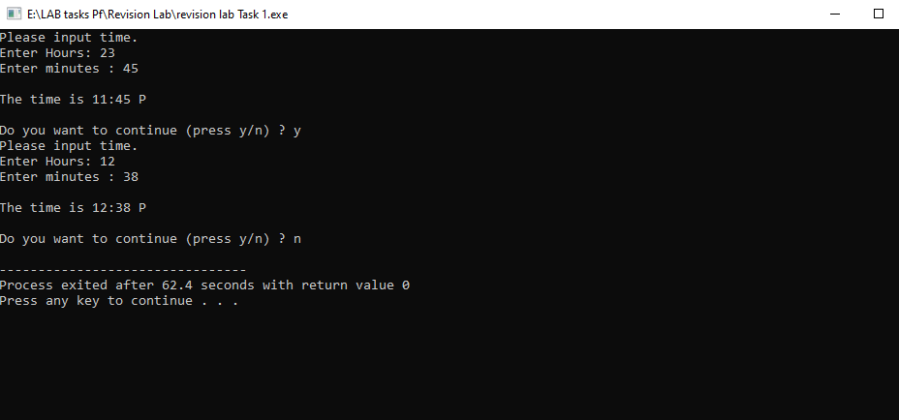

TASK 2.
Input
#include<iostream>
using namespace std;
int main()
{
char check;
do

{
int c_time1,c_time2, w_time1, w_time2, f_time1, f_time2, r_time1, r_time2;
cout<<"Please input time.\n";
cout<<"Enter current time (Hours): ";
cin>>c_time1;
cout<<"Enter current time (minutes) : ";
cin>>c_time2;

cout<<"Enter waiting time (Hours): ";
cin>>w_time1;
cout<<"Enter waiting time (minutes) : ";
cin>>w_time2;

if(c_time1>=0 && c_time1<24 && c_time2>=0 && c_time2<=59 && w_time1>=0 && w_time1<24 && w_time2>=0 && w_time2<=59 )
{
if(c_time1==0 && c_time2>=0 && c_time2<=59)
c_time1=12;
if(w_time1==0 && w_time2>=0 && w_time2<=59)
w_time1=12;

f_time1=c_time1+w_time1;
if(f_time1>24)
f_time1-=24;

f_time2=c_time2+w_time2;
if(f_time2>59)
{

r_time2=f_time2-60;
f_time1+=1;
f_time2=r_time2;

}

if(f_time1>24)
f_time1-=24;

cout<<endl<<"Your Final time will be "<<f_time1<<" : "<<f_time2;
}
else
cout<<"\nInvalid Entry..... ";

cout<<"\n\nDo you want to continue if yes input (y): ";
cin>>check;

}
while(check=='y');

return 0;
}
OUTPUT
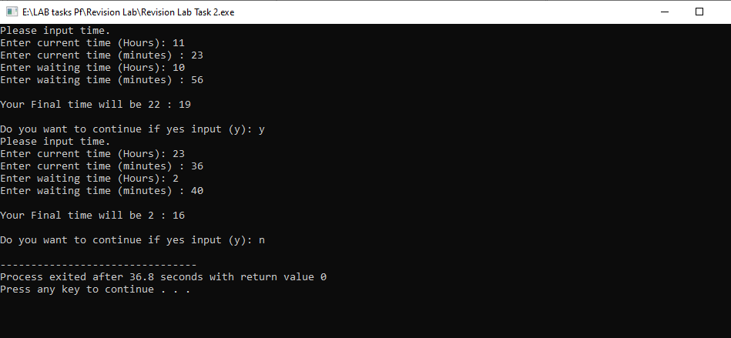

TASK 3.
INPUT
#include <iostream>
using namespace std;
bool isLeapYear(int year);
int getCenturyValue(int year);
int getYearValue(int year);
int getMonthValue(string month, int year);
int main ()
{
int day, year, sum , rem;
string month;
cout<<"Note: The first letter of month must be 'Capital' and all other letters must be 'small'\n\n";
cout<<"Enter month date and year (i.e. July 4 2004) \n";
cin>>month>>day>>year;
bool check=isLeapYear(year);
if((month=="April" ||month=="June" ||month=="September" ||month=="November") && day>30)
cout<<"\n"<<month<<" has maximum 30 days\nInvalid Entry";
else if(month=="February" && day>28 && check==false)
cout<<"\n"<<month<<" has maximum 28 days because Year is not a leap year \nInvalid Entry";
else if(month=="February" && day>29 && check==true)
cout<<"\n"<<month<<" has has maximum 29 days in a leap year\nInvalid Entry";
else if((month=="January" ||month=="March" ||month=="May" ||month=="July" ||month=="August" ||month=="October" || month=="December")&& day>31)
cout<<"\n"<<month<<" has has maximum 31 days \nInvalid Entry";
else if(month=="January" || month=="February" ||month=="March" ||month=="April" ||month=="May" ||month=="June" ||month=="July" ||month=="August" ||month=="September" ||month=="October" ||month=="November" ||month=="December")
{
int MonthValue=getMonthValue(month,year);
int YearValue=getYearValue(year);
int CenturyValue=getCenturyValue(year);
if(day>=1 && day<=31 && MonthValue!=100 )
{
sum=day + MonthValue + YearValue + CenturyValue ;
rem=sum%7;
if(rem==0)
cout<<"The day will be Sunday ";
else if(rem==1)
cout<<"The day will be Monday ";
else if(rem==2)
cout<<"The day will be Tuesday ";
else if(rem==3)
cout<<"The day will be Wednesday ";
else if(rem==4)
cout<<"The day will be Thursady";
else if(rem==5)
cout<<"The day will be Friday ";
else if(rem==6)
cout<<"The day will be Saturday ";
}
}
else
cout<<"\nInvalid Entry";
return 0;
}
bool isLeapYear(int year)
{
if(year%4==0 && year%100!=0)
return true ;
else
return false;
}
int getCenturyValue(int year)
{
int first2Digits , rem, result;
first2Digits=year%10000/100;
rem=first2Digits%4;
result=(3-rem)*2;
return result;
}
int getYearValue(int year)
{
int last2Digits , rem, result;
last2Digits=year%100;
result=(last2Digits/4) + last2Digits;

return result;

}

int getMonthValue(string month, int year)
{
if((month=="January" && year%4!=0) || month=="October" )
{
return 0;
}
if((month=="January" && (year%4==0 && year%100!=0) ) || month=="April" || month=="July")
{
return 6;
}
if((month=="February" && year%4!=0) || month=="March" || month=="November" )
{
return 3;
}
if((month=="February" && (year%4==0 && year%100!=0)) || month=="August")
{
return 2;
}
if(month=="May")
{
return 1;
}
if(month=="June" )
{
return 4;
}
if(month=="September" || month=="December" )
{
return 5;
}
else
{
return 100; // here 100 is any temporary value and shows that month is invalid
}

}
OUTPUT
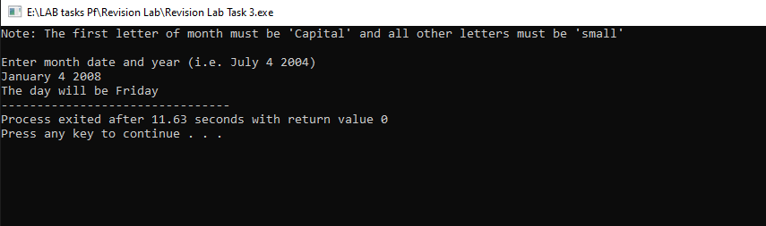
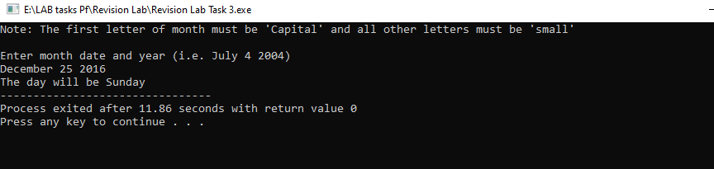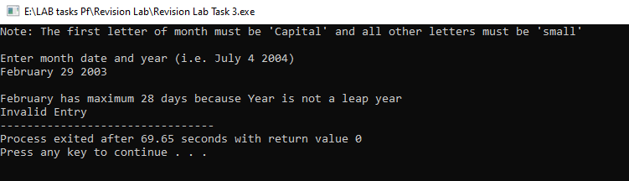
TASK 4
INPUT
#include <iostream>
using namespace std;
#include <string>
#include <cmath>
int hexaTodecimal1(string);
string decimalToHexadecimal(int decimalNum);
int main()
{
char ask;
do
{
string num1, num2;
cout << "Enter a first hexadecimal number ";
cin >> num1;
cout << "Enter a second hexadecimal number ";
cin >> num2;

long Num1Decimal=hexaTodecimal1(num1);
long Num2Decimal=hexaTodecimal1(num2);

long decimalNum = Num1Decimal + Num2Decimal;

if(decimalNum<99999999 && decimalNum>0)
{
string hexNum = decimalToHexadecimal(decimalNum);
cout << endl << "Sum of Hexa representations: " << hexNum << endl;
}
else
cout<<"\nAddition Overflow ";
cout<<"\nDo you want to continue ? ";
cin>>ask;
}while(ask=='y');
return 0;
}
int hexaTodecimal1(string num1)
{
int decimalnum1 = 0, temp1 = 0;
for (int i=0;i<num1.length();i++)
{
if (num1[i]>='a' && num1[i]<='f')
temp1=num1[i] - 'a' +10;
else if (num1[i]>= 'A' && num1[i] <= 'F')
temp1 = num1[i] - 'A' + 10;
else if (num1[i] >= '0' && num1[i] <= '9')
temp1 = num1[i] - '0';
else
{
cout << "Invalid Entry.";
return 0;
}
decimalnum1 += temp1 * pow(16, num1.length() - 1 - i);
}
return decimalnum1;
}
string decimalToHexadecimal(int decimalNum)
{
string hexNum;

// Special case for 0
if (decimalNum == 0) {
hexNum = "0";
} else {
int digits = 0;
while (decimalNum > 0)
{
int remainder = decimalNum % 16;

// Convert remainder to hexadecimal digit
char hexDigit;
if (remainder < 10)
{
hexDigit = remainder + '0';
}
else
{
hexDigit = remainder - 10 + 'A';
}
hexNum = hexDigit + hexNum;
decimalNum /= 16;
}
}
return hexNum;
}

OUTPUT
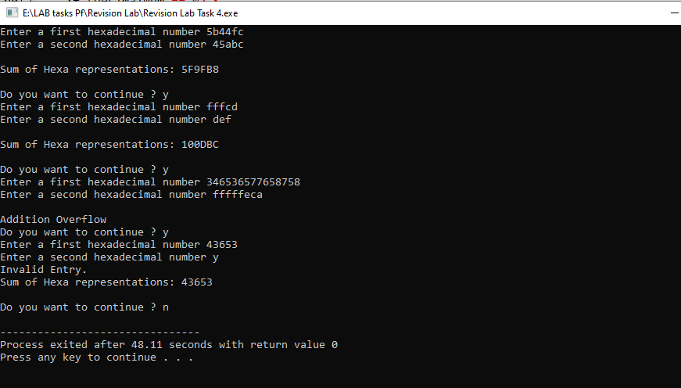

TASK 5
INPUT
#include <iostream>
using namespace std;
int main ()
{
int ask;
cout<<"How many numbers do you have ? ";
cin>>ask;

int numbers[ask], check[ask] ;

cout<<"Enter numbers \n";

for(int h=0; h<ask; h++)
{
cout<<"\t";
cin>>numbers[h];
}

for(int i=0; i<ask; i++)
{
for(int j=0; j<ask; j++)
{
if(numbers[j]<=numbers[i])
{
int temp=numbers[j];
numbers[j]=numbers[i];
numbers[i]=temp;
}
}
}

for(int i=0; i<ask; i++)
{
check[i]=0;
for(int j=0; j<ask; j++)
{
if(numbers[i]==numbers[j])
{
check[i]+=1;
}
}
}

cout<<"\n\n";
cout<<"\tN\tCount\n";
for(int i=0; i<ask; i++ )
if(numbers[i]!=numbers[i+1])
cout<<"\t"<<numbers[i]<<"\t"<<check[i]<<endl;

return 0;
}

OUTPUT
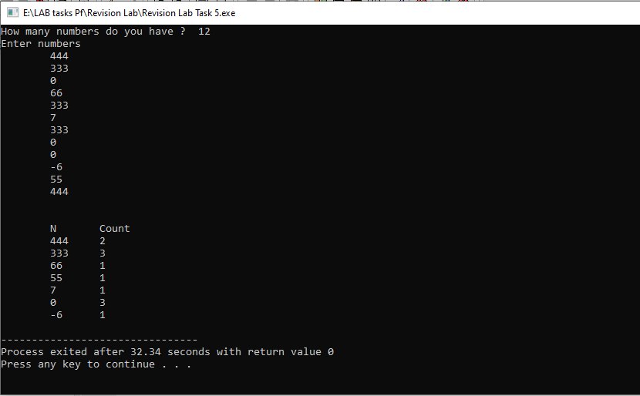

The End

